Peter Julius M. Estacio
Grouped with:
Niño Aloysius V. De Mesa
Christian James S. Madariaga
ENGG 151.01-A
March 11, 2026

Progress Report 3 for Project 2: Fourier Transform

As of March 11, 2026, major progress has been made since the second progress report. The program can now be invoked from the command line, taking in arguments for the relevant file parameters and DFT calculations. These arguments are stored in the program and used throughout runtime for calling the computeDFT() function and to produce an output file. Additionally, the program is now able to both output to console and file output. However, the logic for console output only for calculations with 10 steps or less is not implemented yet. Further work includes implementing this logic and assuring that the program follows specifications. The screenshot of the results shown are below.
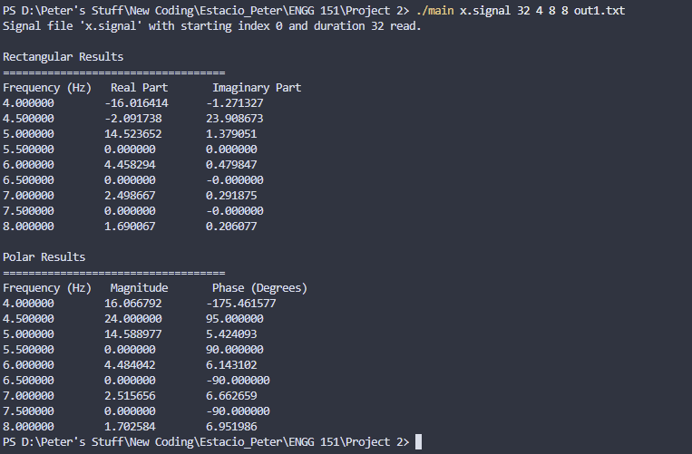
sample screenshot – executable main.exe run and resulting output to console

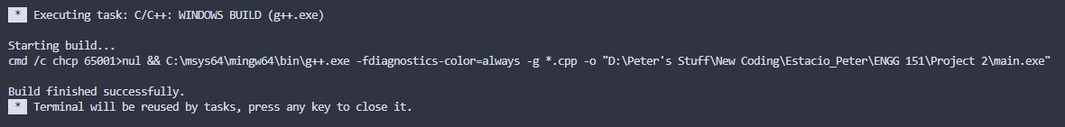
sample screenshot – compilation on Visual Studio Code

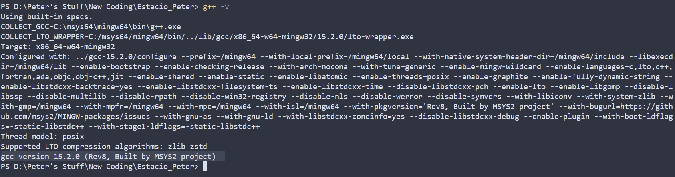
compiler version – gcc version 15.2.0 (Rev8, Built by MSYS2 project)

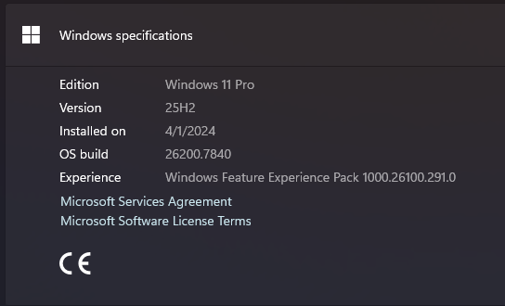
operating system - Windows 11 Pro, 25H2, build 26200.7840

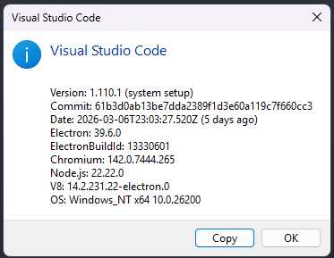
IDE – Visual Studio Code ver 1.110.1

